**PROJECT DESIGN PHASE**

**-**

**1**

**SOLUTION**

**ARCHITECTURE**

Solution Architec

ture

:

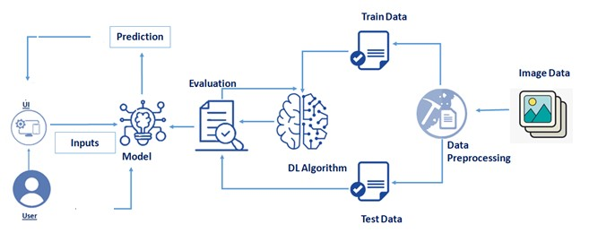

Date

09/11/2022

Team ID

PNT2022TMID19703

Project Name

AI Powered Nutrition Analyst for

Fitness Enthusiasts.

Maximum Marks

Marks

2